Monday, February 23, 2026 HOA Board Meeting
Call to Order 6:34

Summary and Action Items:
- Coffee Social happening Sunday, March 1 from 10-12. Please attend!
- Board Election Nomination Deadline: March 9. Please run!
- Curb repair: Olivia is collecting bids for vendors. Invoice will be sent to garbage company.
- Stein Claim: Mediation with Farmer’s March 30 at 9am. Meeting with QBE shooting to schedule for late March
- Fallen Branch near Entrance: Olivia to look at it on next site visit to see if we need to remove it if it’s a danger. We may just leave it if it’s not a danger and is purely cosmetic.
- Road Repairs:
  - Walkthrough with Sealcoat King targeting Friday, 2/27 at 9am
  - Point out missing middle stripe/reflectors, damage in front of buildings 15 and 16 (Kris sent photos) and pothole (plus any additional potholes found)
  - For Pothole Repair: Authorized board at discretion to approve one of these three bids as a result of the walkthrough on Sealcoat King on Friday in amount up to $5100.
    - Eagle Asphalt- $5,100
    - Valley Asphalt- $1,323
    - Rainier Asphalt- $5,052
- Meeting transcripts: Still need transcripts from December budget meeting and January meeting (full transcripts, NOT AI SUMMARIES)
- Rules Rework: Plan to accept on March 16, then go over it at Annual Meeting with information on how to give feedback. (note: to do this we must designate March 16 as a formal board meeting and not a working session)

Full Notes
Open Forum
- Prof reminded about coffee and donut social on Sunday
- Carol asks about pothole. Prof notes we’ll discuss it in the road repair section
- Carol asks about progress on if we’ve heard from garbage company about the curb repair? Olivia is collecting bids for vendors.
Meeting minutes approval
- Approved. Action Item: Prof to make sure non-watermarked version gets put on website
Financials
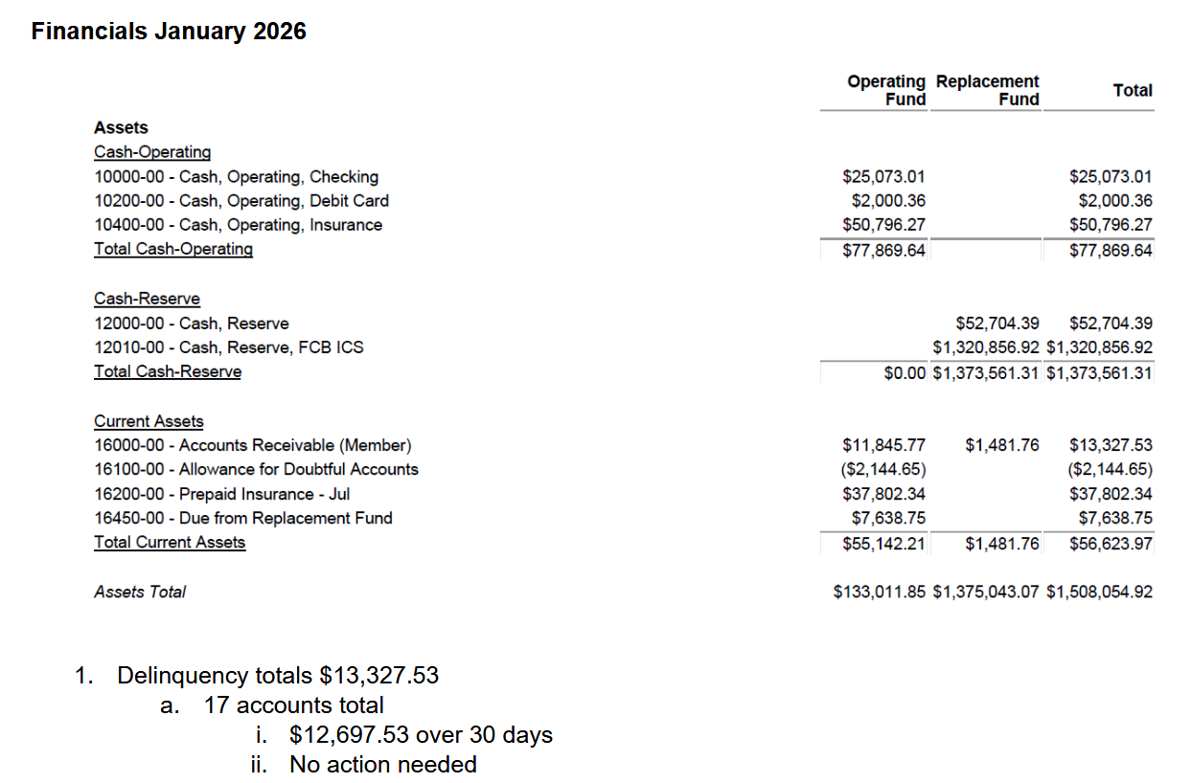
Old Business
- Maintenance Requests
  - Prof asks if we can discuss the summaries in email or if they have to be in a meeting. Olivia said she’d double check
- Building 4 panel
  - Contract approved and signed, scheduling for next week
- Stein Claim
  - Justin – reminds that we have mediation on March 30 at 9am with farmers (in person) or give proxy if not able to be there physically. JDR on 4th avenue
  - QBE – Will be in contact with Curtis and Tyler. looking to schedule late March
  - Curtis reminds that board elections are the evening on March 30 so we should talk about if that’s gonna be an issue
  - Money is earmarked for siding replacement
- Landscape
  - Tree has been removed from roof
  - Another branch came down near entrance – can landscaping remove it or do we need a tree person? Probably just cosmetic, but may want to check . ACTION ITEM: Olivia to look at it on next site visit to see if we need to remove it. If it’s a danger. We may just leave it if it’s not a danger
- Pest
  - Green City, arranging first visit date this week.
  - Saela has been given notice
- Road repairs
  - Prof is available for walkthrough this week. Try to schedule for this Friday at 9am.
  - Pothole repairs
    - Curtis – Usually do repairs at same time as sealcoat, we didn’t last year because cost went up 500%. As a result, contract was extremely barebones.
    - Tyler noted that Sealcoat did have a 12 month guarantee. They mentioned we should probably repave within the next 5 years. Last paving bid was $250k for an entire repave.
    - Notice that repairs tend to only last around 5 years. Notes that we eventually have money set aside to eventually do full resurface. Action Item: Olivia
    - Kris brings up stripe up middle/reflectors as things that need to be Sealcoat needs to do. Action Item: bring this up on walkthrough on Friday. Kris to send photos of repairs needed in front of 15 and 16. Note additional potholes on Friday.
    - Curtis – breakeven financially would be to repair potholes until the cost exceeds $20k a year until we consider repaving
    - Authorize board at discretion to approve one of these three bids as a result of the walkthrough on Sealcoat King on Friday in amount up to $5100.
      - -Eagle Asphalt- $5,100
      - -Valley Asphalt- $1,323
      - -Rainier Asphalt- $5,052

New Business
- Annual Meeting set for March 30. Prof encourages folks with questions to come out on the Sunday Social to ask questions.
- Roof inspection with Steadfast
  - Steadfast to meet Juan on site for roof inspection.
  - Kris asks if they can also look at gutters if any need replaced. Tyler noted that Interlake already did this.
  - Olivia will follow up to confirm that this gets scheduled
  - Carol – Why always steadfast? Curtis – they’re the most familiar with our projects and property, usually lowest vendor, cost associated to switching so we want them to be able to at least bid. Not
- Went over action items from last meeting
  - We need transcripts from Budget meeting, January, and now this meeting (note, NOT AN AI SUMMARY, we need the transcript)
- Rules Rework
  - Final readthrough of Curtis’s changes
  - Accept officially in Work session meeting, targeting March 16
  - Action item: Trestle to send out mail to homeowners along with notice of Monday work sessions, with note that 16th will be about rules. Note this should include a generic agenda for work sessions
  - Go over it at Annual Meeting and explain the feedback process
  - Mail out to homeowners

Motion to move to executive session at 7:43
- Discussed legal topics, no action items

