Call to Order 6:33

Summary and Action Items
- On-site inspections
  - Juan to send a recap of findings on next on-site
- Sealcoat problems (potholes and stripes)
  - Juan to investigate litigation over Sealcoat King unresponsiveness
  - Investigate handy-man option for repainting missing stripes (potential volunteer action?)
  - Juan to get inspect pothole on his visit (Carol has sent a photo)
- Bedframe behind trash area near Building 1
  - Curtis will get rid of this to prevent paying for another visit from Northwest
- Board contact info
  - Prof will post a reminder flyer in the clubhouse with the email contact for the board
- Financials and cash reserves
  - Motion approved for board to pick bank, amount, term and rate for investment offline and execute authority to invest.
  - Rushabh volunteered to work with Curtis on this
- Maintenance Requests
  - Juan to start automatically adding requests that we complete to agenda so they’ll be recorded in the minutes
- Building 4 panel
  - Board Approved bid from Max Power to complete this work ($43,810)
- Roofing assessment
  - Juan to have Steadfast assess the state of our roofs, which were replaced 20 years ago, to get an idea of when the next replacement should be.
- Rules Update
  - Final board look at Tyler’s version
  - Send email with rules “patch notes,” rules draft to owners for feedback, noting to discuss on Frontsteps
  - Tyler to create thread on Frontsteps for owner feedback for 30 days
  - Afterwards, board will look at feedback and decide what to do with it.
- Pest Control
  - Board approved bid from Green City to complete this work
  - Green City - $240 set up / $3,576 a year for 2x month visits pest and rodent w 16 bait stations
- Board Elections in March
  - 3 positions will be open
  - Prof to rally volunteers to help with information campaign to encourage people to run
- HOA Meeting logistics
  - HOA meetings will take place last Monday of Every Month
  - May will be on the 18th because of Memorial Day on the 25th
  - Standing Meetings for working sessions on Mondays at 6:30. Cancellations can be posted on the website with the link
  - Curtis to give Juan a generated link to use with the notice
  - Juan to send Curtis the recording and transcription for this meeting and the Budget ratification meeting
- Stein Claim actions
  - Confirm Curtis and Tyler can negotiate with the authorization of the board on insurance claims (negotiate, accept settlements, and confirm agreements)
  - Approve recommendations for Farmers mediation and QBE Settlement Conference
  - Confirm approvement of settlement of Guide One
  - Board in general has authority to set up Mediations and Settlement Discussions, negotiate and issue demands, settle for amounts in best interest of the association, and approve final settlement agreements.
- Quarterly Socials
  - Board motioned to establish social committee to organize and host quarterly socials based on volunteer time and contributions, authorize purchases up to $100 for supplies and food.
  - Prof to inform Erica so she can start planning next social
Adjourned at 8:12

Full Notes
----------------

Owner Forum
Carol – changing middle bathroom tub into a shower, what do we need from the board? Just submit a formal request with whoever you’re working with. Note to check for polybutylene line because HOA can pay to replace those.
Carol – asking about what Juan looks for during property reviews. Steadfast debris left two months after the project was done, why wasn’t it flagged? They took up two handicap parking spots, is that legal? Juan acknowledges concerns. Noted people storing things on balconies and why Juan doesn’t call them out. He says he’ll be out on site this Wednesday.
Kris – requests Juan send a recap of his walkthroughs. Juan says it’ll be the last week of each month. ACTION ITEM: Juan to send recap of next on-site
Andrea – can we get a center stripe painted on the entrance driveway because people are taking curves up the middle and it’s dangerous. The reflectors were not replaced either. Juan notes that Sealcoat King has been ghosted. ACTION ITEM: Sealcoat King potential litigation over unresponsiveness, we could get a handyman to come do the stripes
Katelyn – there is trash in the dog area near Building 1, behind enclosure, who is responsible to remove it. ACTION ITEM: This has been on Juan’s to-do list since summer, he says he’s gotten trash removal people to come out. Juan to get on Northwest’s case about it.
Carol – there’s a hole in the asphalt past the clubhouse. ACTION ITEM: Juan will get a photo of it on Wednesday.
7-303 – asked about the process of delinquency fees. Auto update didn’t consider the new price, but received no notification about delinquency. Email looked like a phishing email. Also had difficulty discussing because couldn’t get through to Trestle on phone. Delinquency notices go out on the 15th, no notifications go alongside it. To discuss one on one via mercerpark@trestlecm.com and Juan will call.
7-303 Email for board? management@mercerpark.org ACTION ITEM: Prof will post something in clubhouse to remind people

Meeting Minutes from October
- Accepted
- Can post them with DRAFT watermark
Financials (copied from Agenda)
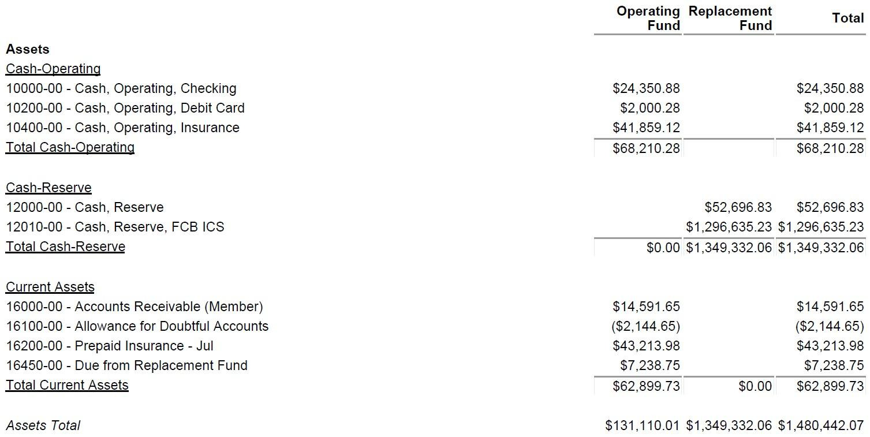
Curtis requesting a rate sheet for assets for cash reserve
Tyler –Motion for board to pick bank, amount, term and rate for investment offline and execute authority to invest. Board approves
Rushabh volunteered to work with Curtis on researching options. Thank you Rushabh!

Old Business
- Maintenance Requests from last month. ACTION ITEM: Juan to start automatically adding requests that we complete to agenda
- Building 4 panel –
  - Max Power - $43,810 BOARD APPROVED THIS OPTION
  - Compass - $62,296
  - Innovative Systems - $69,928
- Interlake gutter work. Kris – they noted roofing looked bad, can we have Steadfast assess the roof? Carol – about 20 years ago.
- Branch through building 4 garage. Has been approved to fix
- Rules update.
  - Final board look at what Tyler’s version is
  - Send email with rules “patch notes,” rules draft to owners for feedback
  - Tyler to create thread on Frontsteps for owner feedback for 30 days
  - Afterwards will look at feedback and decide what to do with it.
- Pest Control bids
  - Rambo - $0 set up / $5,988 a year for 12 visits pest and rodent, quarterly cycle 16 bait stations
  - United - $550 set up / $1,350 a year for 6 visits pest and rodent w 16 bait stations
  - Green City - $240 set up / $3,576 a year for 2x month visits pest and rodent w 16 bait stations BOARD APPROVED THIS OPTION

New Business
- Board elections in March
  - Three positions open (Prof, Curtis, Elizabeth’s interim position)
- Meeting logistics
  - HOA meetings last Monday of Every Month
  - May will be on the 18th because of Memorial Day on the 25th
  - Standing Meetings for working sessions on Mondays at 6:30. Cancellations can be posted electronically
  - Clarification on if DISCUSSIONS or DECISIONS cannot happen outside of meetings
    - Juan says that discussions and coordination can happen in email, the decisions have to happen in meetings
  - Teams link, Curtis is concerned that since the meeting is set up by Trestle, Curtis does not have access to recordings, review, it’s separate from the board’s teams site. Why can’t we continue to do it through the board teams site?
    - Juan, it’s important for the link to be the same in order to be able to do the whole year in one notice
    - It’s fine to use the board’s link, it just needs to be the one link
    - ACTION ITEM: Curtis to give Juan a board-generated link
  - Process for cancellation: no legal requirement.
  - ACTION ITEM: Juan to send recording and transcription for this meeting and the Budget ratification meeting
Motion to adjourn to executive session
7:33
Return from executive session at 7:50
Stein Claim actions
- Confirm Curtis and Tyler can negotiate with the authorization of the board on insurance claims (negotiate, accept settlements, and confirm agreements)
- Approve recommendations for Farmers mediation and QBE Settlement Conference
- Confirm approvement of settlement of Guide One
- Board in general has authority to set up Mediations and Settlement Discussions, negotiate and issue demands, settle for amounts in best interest of the association, and approve final settlement agreements.
Board motions to approve all of these
Regular Socials
Motion to establish social committee to organize and host quarterly socials based on volunteer time and contributions, authorize purchases up to $100 for supplies and food.
Board approved

Motion to adjourn at 8:12

