April 27, 2026 Monthly Meeting
Call to Order 6:35
Summary and Action Items
- Trestle to follow up on Rainier to repair pothole and get them on the calendar
- Trestle to contact owners in 8-202 to make sure their AC unit has been properly installed (no drilling into siding)
- Trestle to send out general reminder about our AC rules to residents (email is fine)
- Trestle to double check when sprinklers will be turned on in May
- Prof to draft some signage about rules regarding dumpling and resources
- Elizabeth to have Jim find photos of clubhouse curb before repainting to verify that stenciling was present
- Trestle to get pricing on what stenciling would be if we have to pay for it
- Trestle to reply with “acknowledged and received” responses to emails from homeowners
- Trestle to resend bid about curb repair so we can approve it
- Trestle to follow up with Sealcoat King and get the additional striping on the calendar, plus inquiring about reflectors which are already breaking and detaching
- Trestle to arrange options for roof assessment from roofing specialist from someone without a vested interest in replacing the roof
- Curtis to generate general ledger spreadsheet to make pivot tables for better assessment of budget.
Home Owner Forum
- Carol: pothole? Action Item: Juan to follow up on Rainier (it’s been since the 7th)
- Carol: 8-202 has drilled into the siding to install a window unit air conditioner. Action Item: Juan to notify home owners to make sure the AC is installed to manufacture specifications (no drilling into the side of the building). General email reminder about our AC rules. Carol to send photo.
- Carol: When will sprinklers turn on? Juan said May. Action Item: double check timing
- Erica: FiL has equipment to do gravel leveling on 118th. Action item: to follow up with Curtis
- Prof: Garden patch/gate/rain barrel.
  - Board approves on following conditions: See if rain barrel will cause visual issues, can move to balcony if so. Planter and gate must match other ones on the property for consistency. Make sure there is proper access for any maintenance needs.
- Elizabeth: dumping in trash areas. Action item: Prof to draft some signage to explain the rule and list resources for where to take bulky items.
- Elizabeth: Stenciling in front of clubhouse on curb? Juan says there wasn’t previously stenciling on that curb. Several residents disagree. Action Item: Jim to find photos from before to see if it was there. Meanwhile Juan can get pricing for what the stenciling would be.
- Carol: What’s the status on the curb repair. Status? Action Item: Olivia to resend bid so we can approve it.
- Elizabeth: Would like acknowledgement from Trestle on emails so it doesn’t seem like it’s going into the void. Action Item: Juan to let Olivia know about this feedback
Previous meeting minutes
- Board approves prior minutes
- Action Item: Prof to remove watermark and re-upload
Financials
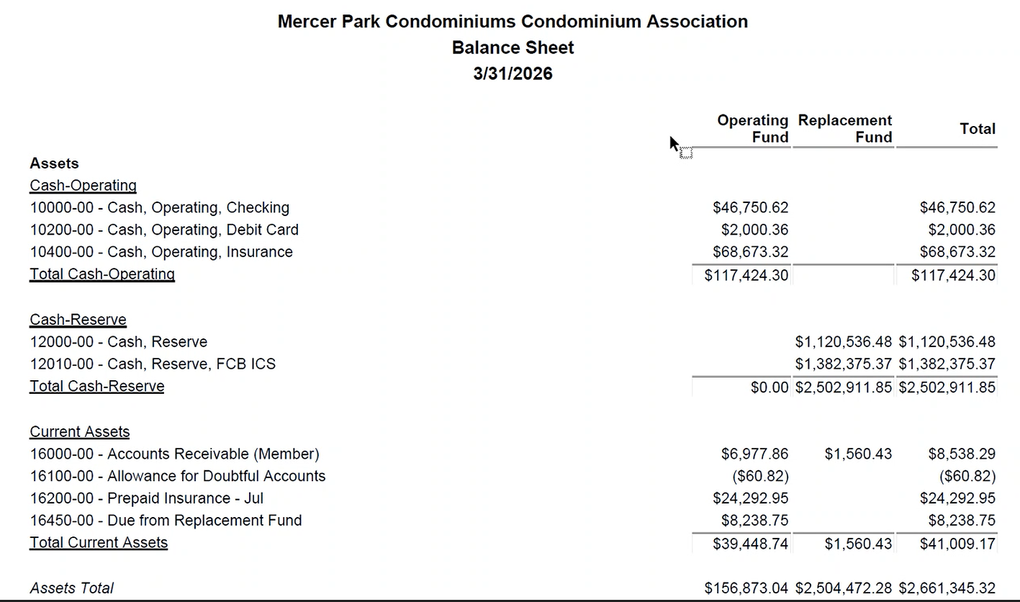
Juan recommends investing some of what is in the money market account to get some interest
- Curtis: waiting for Trestle to send rate sheets. Homeowner to volunteer to help analyze rate sheets. Action Item: Juan to send rate sheets, note terms and packaging. Board would have to set up having statements sent to Trestle
Old Business
- Pothole repair: Action item to get that on calendar
- Sealcoat King to do additional striping. Action Item: Follow up to get on schedule. And bring up reflectors
  - Kris notes that their reflectors are already breaking and coming off already.
New Business
- Volunteer Project for habitat restoration.
  - Board approves Prof to call together volunteers to assist in ivy removal/habitat restoration on property facing 118th, and manager communication. Prof granted approval to use discretionary funds debit card for supplies and send in receipts not exceeding $100 a month
  - Elizabeth mentioned planting bulbs in planters and around property. Action Items: Carol recommends daffodils, will provide more recommendations. Elizabeth to take photos of recommended locations for work.
- Roof Replacement discussion. Probably $1.5 million, probably 10 year lifespan.
  - Action Item: Arrange options for roof assessment from roofing specialist from someone without a vested interest in replacing the roof (architecture firm)
Adjourned main session to go into executive session to discuss advice from legal counsel and existing or potential litigation or arbitration.
The Board authorizes the Association’s attorney to pursue all remedies and options for reimbursement of the second check deposited by the owner of Unit 4-101, including without limitation making demands for reimbursement. The Board President is authorized to review and approve such demands and actions on behalf of the Board, without the need for a further vote of the Board. However, the commencement of a lawsuit or arbitration must be approved by the Board.
Action Item: Curtis to generate general ledger spreadsheet to make pivot tables for better assessment of budget.
Adjourned at 7:54

