June 1, 2026
Call to order 6:32

Summary and Action Items
- Board Approvals
  - Approved Cedar Creek bid for curb repair
  - Approved invoice for loss event in 6-101
  - Board made decisions regarding determination of cost for 5-103
  - Approved Trestle project office to handle 12-202, 12-102, 6-101.
  - Decided on course of action for hardwood floor violation 7-201.

- Action Items for Trestle
  - Carpenter Ant reports. Scott will ask Olivia to give all concerned homeowners a status update. Curtis says to ask specifically for bait
  - Scott to follow up with Olivia about the request from last HOA meeting that Trestle acknowledge homeowner emails. Homeowners are still getting no response to their questions and requests.
  - Sealcoat Striping: Ask Olivia to follow up and push back. We have additional photos showing where the previous striping was, as you can currently see remnants of the old striping through the sealcoat.
  - Irrigation Repairs: Inform Oliva that for irrigation repairs, if it’s within Trestle’s purchase authority they should just do them.
  - Irrigation Repairs: Olivia to get ballpark of time and materials section so we can set Do Not Exceed amount
  - Irrigation Repairs: Follow up with Eastside on timeline and status of irrigation so we know if we need to do emergency watering
  - Laurel Law Invoices need to be paid by Trestle. These have already been board approved Trestle to pay invoices 10489, 11629, and 11510
  - General Maintenance Issues: For timely proposals (like the irrigation repairs), send them to the board immediately and we can approve them in a worksession meeting, don’t wait until the monthly because it pushes everything back.
  - Landscaping: Olivia to follow up on whether or not Eastside is taking initiative on issues
  - Landscaping: Get bids on mulching
  - Reserve Study: We don’t want to use the same company as last year, get bids on other companies we could use. Include new companies and ones we’ve used before (ReserveStudyGroup.com, Schwindt). Scott recommends Accurate Reserves
  - Building Washing: Get bids for soft-wash for buildings and power-wash for railings
  - Touch-up Painting: Find vendors for touch-up painting on time and material bases. Juan said he struggled finding people, we’d like to know who he tried, we want handyman style vendors, not painting companies. When it’s done, company should note on invoice the areas done.
  - Walkthroughs: Follow up on the status of the walk-around maintenance work orders that the board already approved, and the expected time these will be fulfilled.
- Action Items for Board
  - For future invoice approvals on maintenance issues, Carol has volunteered to do thorough walkthroughs to confirm work completed.
  - On-site members should keep an eye out for landscaping issues
  - Board Guidance Proposal that external failure of pipe issues is responsibility of HOA, noting that the bylaw contradicts and that future boards may not adhere to it.
  - Tyler to assist with researching bids for touch-up painting
  - Prof to update last month’s minutes on site and remove watermark

Full Notes

Homeowner Forum
- Prof: Reminder summer social
- Carol: carpenter ants, never heard back from Olivia, what is the expected turnaround? Action item: Scott will ask Olivia to give all concerned homeowners a status update. Curtis says to ask specifically for bait
- Elizabeth: asked Juan to speak to Olivia about acknowledging homeowner contact/follow-up last meeting. This hasn’t happened. Action item: Scott to follow up
- Carol: Automatic withdrawal for dues, getting paper statement. How do opt out? Scott: can opt-out of paper documents in FrontSteps. Kris says she opted out but still get paper statements. Action item: Trestle to follow up with paper statement opt-out. Send notification to homeowners on how to opt out.
- Katelyn: Clubhouse door handle not working, check in. Someone came and fixed it the other day so should be fixed.
- Curtis: What should people be able to see in Front Steps. Can all homeowners see work orders to common areas? Can board members see homeowner work orders? Action Item: Scott to follow up with Olivia to make sure Frontsteps has reactivated permissions for board (board should be able to see everything)

Approval of Minutes
- Board approved
- Action Item: Prof to update and remove watermark

Financial
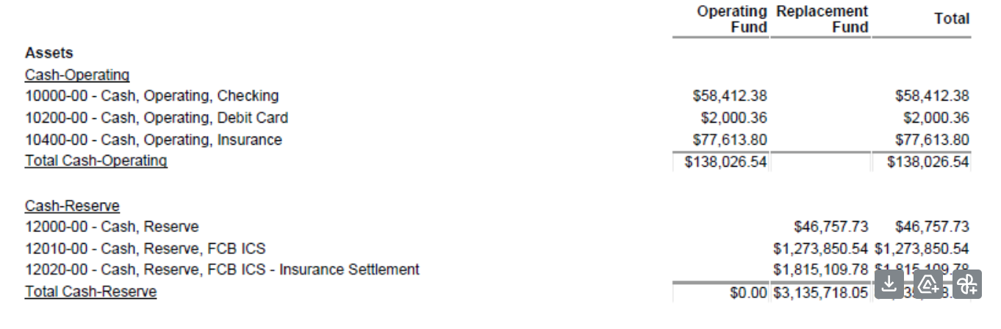
- Carol asks for update on assessment. Tyler thinks most people are doing on montly

Old Business
- Pothole repairs: Done!
- SealCoat King – striping pushback. Reflectors have also not been replaced as we asked. Action item: Scott to ask Olivia to follow up with board with exact wording she sent. We want to keep pushing back.
- Carol volunteering to do thorough walkthroughs before we pay invoices to prevent this from happening in the future.

New Business
- Cedar Creek Proposals for Curb Repair
  - $3019.48
  - Association will pay up front, trash company to pay back
  - Action Item: Ask if Cedar Creek could bid striping, stenciling, and reflectors to see if we can have them do it when repairing the curb
  - Board approves the bid.
- Landscaping and Spring irrigation repairs
  - 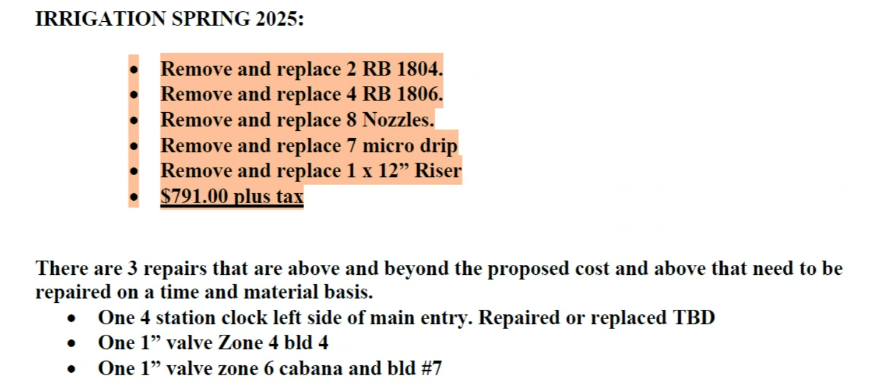
  - Is this within Trestle’s purchase authority? Oliva wanted to bring up.
  - Board approves the repairs but will wait for more information on the time and materials section.
  - Action Item: Inform Oliva that for irrigation repairs, if it’s within Trestle’s purchase authority they should just do them.
  - Curtis asks if Eastside is taking initiative for problems. Action item: Olivia to follow up to see if this is happening
  - Kris asks if Landscaping are putting down mulch, do we want to bid it out? Action Item: Trestle to get bids on mulching
  - Carol asks when to expect the irrigation to be turned on. Scott said they will turn it off after making the listed repairs.
  - Action Items: Olivia to get ballpark of time and materials section so we can set Do Not Exceed amount
- 2027 Reserve Study
  - We are not happy with the same reserve study company, last year’s was completely wrong and the company argued with us about it.
  - Action item: Research other companies that we could use, include the companies we used before as some of the bids (ReserveStudyGroup.com, Schwindt). Scott recommends Accurate Reserves
- Water loss in unit 6-101 Invoice NW
  - Board approves the invoice for $3472.08
- Laurel Law invoices
  - These have been approved by the board but need to be paid by Trestle
  - Action Item: Trestle to pay invoices 10489, 11629, and 11510
- Other questions, project schedule
  - Curtis: Does Trestle have a calendar of scheduled projects so we can bring them up in a timely manner? We are worried we are going to miss the timeline for things like painting and building washing.
  - Kris asks every year to schedule cleaning in spring instead of summer because it’s difficult to move things.
  - Action Item: For timely proposals (like the irrigation repairs), send them to the board immediately and we can approve them in a worksession meeting, don’t wait until the monthly because it pushes everything back.
  - Action: check for any landscaping issues
  - Action item: what is current status of irrigation system (do we need to do emergency watering)
  - Action Item: get building soft-wash bids, pressure wash for railings
  - Action Item: Follow up on the status of the walk-around maintenance work orders that the board already approved, and the expected time these will be fulfilled.
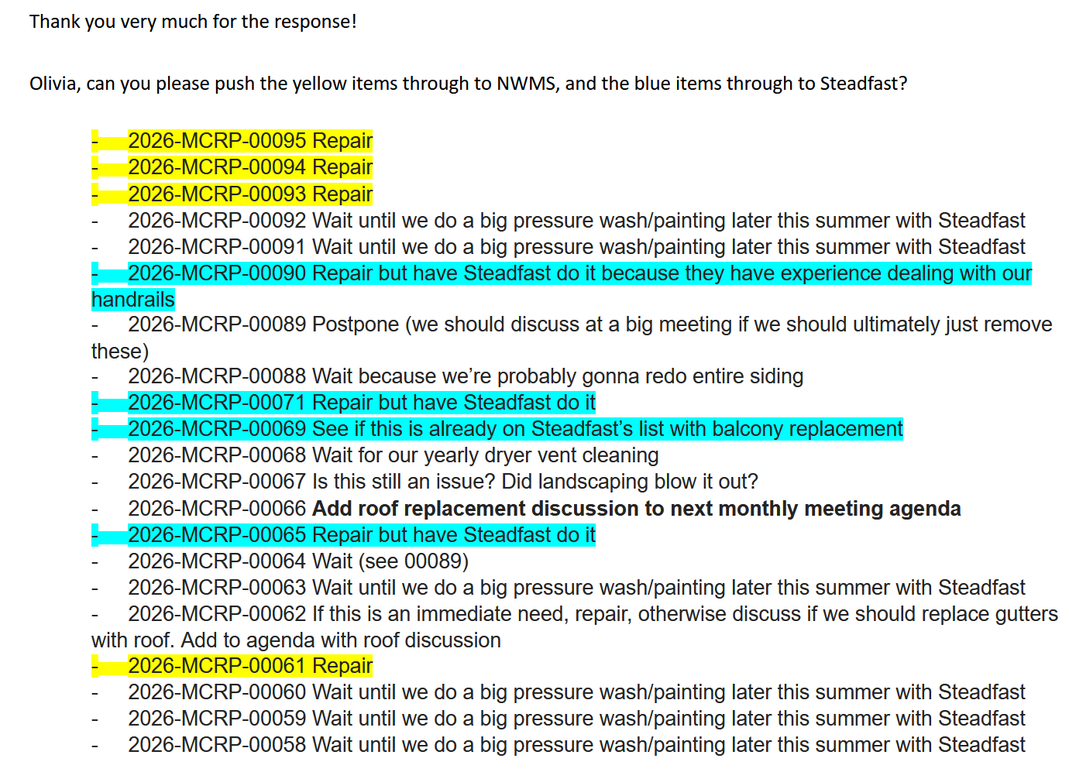
  - Action Item: Find vendors for touch-up painting on time and material bases. Juan said he struggled finding people, we’d like to know who he tried, we want handyman style vendors, not painting companies. When it’s done, company should note on invoice the areas done.
  - Action Item: Tyler to help research vendors for touch-up painting
Adjourned to Executive Session at 7:45
Board made decisions regarding determination of cost for 5-103, approved Trestle project office to handle 12-202, 12-102, 6-101. Decided on course of action for hardwood floor violation 7-201. Discussed privileged legal matter.
Board Guidance Proposal that external failure of pipe issues is responsibility of HOA, noting that the bylaw contradicts and that future boards may not adhere to it.
Adjourned 8:33

