June 29, 2026
Call to Order 6:32pm

Summary and Action Items
- Tree pruning in front of buildings: Olivia will reach out for arborist options
- Balcony use: Olivia will send a notice and Prof will print it out and post in the clubhouse
- Missing Parking passes: Curtis will take a look at the cars parked in front of building 8 since parking patrol volunteers have been busy
- Olivia to check for months were the general ledger was missing from the financial report and resend
- Olivia to send itemized breakdown of the $70k uninsured loss
- Olivia to investigate if there’s a way to get the financial information in excel format
- Dryer Vent cleaning -
  - Board rejected reimbursement request for property that cleaned vents without going through the proper maintenance channels
  - Board approves Apex Ventilation LLC - $2419.
  - Missing Dryer vent covers - Olivia to check if this would be within Trestle’s purchase authority, and if so go ahead and take care of it
- Mulch replacement – Board approves Eastside $9,640
  - Olivia to arrange on-site meetup with Eastside before this is done, so we can go over things that were problems last time (like overfilling the areas above lower units)
- Fire Extinguisher Box Replacement – Board approves Euro Maintenance $85/hr
  - Prof to purchase the boxes in advance
- Striping and Reflectors
  - Board approves Cedar Creek to do work up to $3k
  - Board to meet Enrique and discuss the work on Monday
- External Soft Washing
  - Board is waiting for additional bids by July 7
  - Olivia to look up SparkleWash and Champion Powerwash bids
- Reserve Study
  - Board approves ull reserve study with either company after more thorough analysis. Will pick by Monday.
  - Olivia to get information both regarding turnaround time for changes
- ACC EV Charger Request
  - The board needs more detailed information about the installation plan. Olivia to arrange meeting between board and the proposed electrician (give the homeowner the option to attend)
  - Board authorizes EV Offline Charger investigation
  - Curtis to get questions together for meeting for 11-301, and ask about 7-202’s proposed plan in the process
- Insurance Renewal
  - Kris has someone for an additional bid for comparison
  - Tyler will reach out to Dustin and Daniel for recommendation
  - Get other recommendations asap because we need to return by mid July.

Full Notes
Homeowner Forum
- Jim (15-102): Gutters are full again. When will Interlaken come back? 15 and 16 have pine trees that fill up the gutters. Last visit was in November. Grates in front of garages are also full. General comment that the site looks gross from moss and pine needles and stuff.
  - Tyler found Interlake bid for spring as well as Fall contract
- Carol: Notes that the Japanese maple trees are being rounded out by the landscapers but they aren’t being properly pruned. Can we get an arborist to look at them in the Fall after the leaves have fallen? Action Item: Olivia will reach out for arborist options
- Carol: Can Trestle send a reminder about balcony etiquette? Units hanging laundry, tarps, clearly being used as storage, boxes in entryways. Remind people that people live below them and don’t dump water down on your downstairs neighbor unexpectedly. Action Item: Olivia to send out email, Prof will print and post in clubhouse
- Carol: Noticed that lots of cars parked don’t have parking passes. Can we crack down? Curtis: Volunteer parking patrol haven’t had a lot of time to do walkarounds recently. Action Item: Curtis will take a look at the cars in front of building 8 if no volunteers available
Approval of previous meeting minutes.
- Curtis: edit comment to indicate time-and-materials instead of handyman. He’ll make the edit and remove the watermark
- Board approved
Financial
Financial Report- Balances below as of 5/31/26. May OP expenses $183,445k, $73,032k over budget for the month due to $70k Building Uninsured Loss. No other significant variances or immediate concerns.
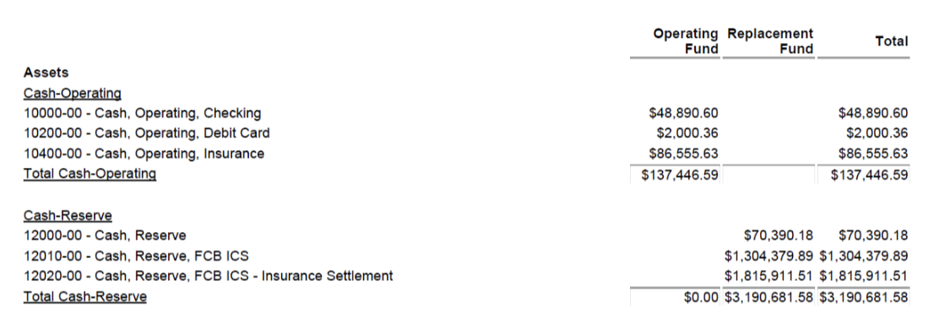
- Curtis noted that general ledger has been removed from our financial reports and asks if we can get it re-added. Olivia noted that it’s there for May. Action Item: Olivia to check if any months were missed.
- Carol asked about the $70k uninsured loss. Olivia confirms that this is many claims in one payment. Action Item: Olivia to send the itemized breakdown.
- Curtis requested if we can get this information in excel form? Olivia doesn’t have access to this. Action Item: Olivia to see if there’s a way to get this information in excel format
- Curtis still can’t get access to board documents.
Old Business
- Garbage bin replacement. No response yet but they have been contacted
  - Carol notes that trash company usually doesn’t put the bin far enough in the area by building 9. Action Item: Olivia to call about this and follow up on the bin replacement
New Business
- Dryer Vent Cleaning
  - Reimbursement Request. Homeowner uses a property management company to manage their rental, had a company do this work without HOA knowledge. They have been notified of the proper way. Do we want to reimburse them?
    - Board moves to deny reimbursement
  - Bid for next cleaning. Miracle Vent no longer an option, but our old tech is at Apex Ventilation LLC - $2419
    - Board approves this bid
    - Kris – can we get a bid on what it would take to replace missing covers? Action Item: Olivia to check if this would be within their purchase authority, and if so go ahead and take care of it
- Bark Mulch Bids.
  - Eastside $9,640
  - Natural Concepts $10,229
  - Board approves Eastside, but we need to make a plan with them to avoid the issues of overfilling the planters that overflowed in underground units and caused flooding. Action Item: Olivia to plan this but with onsite meetup beforehand with one of the board members
- Fire Extinguisher boxes
  - Euro Maintenance $85/r
  - Valley Property Services $105/hr
  - Board approves Euro Maintenance. Action Item: Olivia to confirm bid and go ahead. Curtis and Prof to coordinate ordering the boxers (we need 15)
    - https://www.uline.com/BL_3927/Steel-Fire-Extinguisher-Cabinets?pricode=WQ871&AdKeyword=fe%20cabinets&AdMatchtype=e&ad_group_id=172623976550&gad_source=1&gad_campaignid=21806161912&gbraid=0AAAAAD_uetOEo0QSQUWA75QftEOh0pt1a&gclid=Cj0KCQjwr4jSBhCSARIsAOX1E-LZMSwfGvBJOOgsLgVHtraSyOE9Badereq8TjUMOfDUSC-Yq_xZIHgaAp0rEALw_wcB
- Cedar Creek striping and reflector proposal $2167
  - Wants to meet with board over Teams to answer questions. Action Items: Olivia to arrange meeting
  - Board approves up to $3k pending Teams discussion
- Exterior Soft Washing.
  - Sound Cleaning - $50,002.66
  - NW will have bid by July 7
  - Board decides to wait for NW bid. Curtis asked about SparkleWash for a third bid option. Action Item: Olivia to look up SparkleWash and Champion Powerwash
- Reserve Study
  - Reserve Study Group
    - 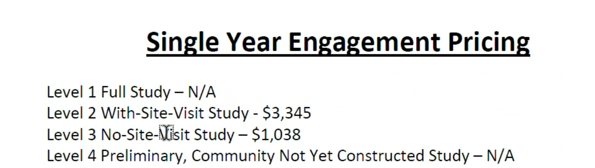
  - Accurate Reserves
    - 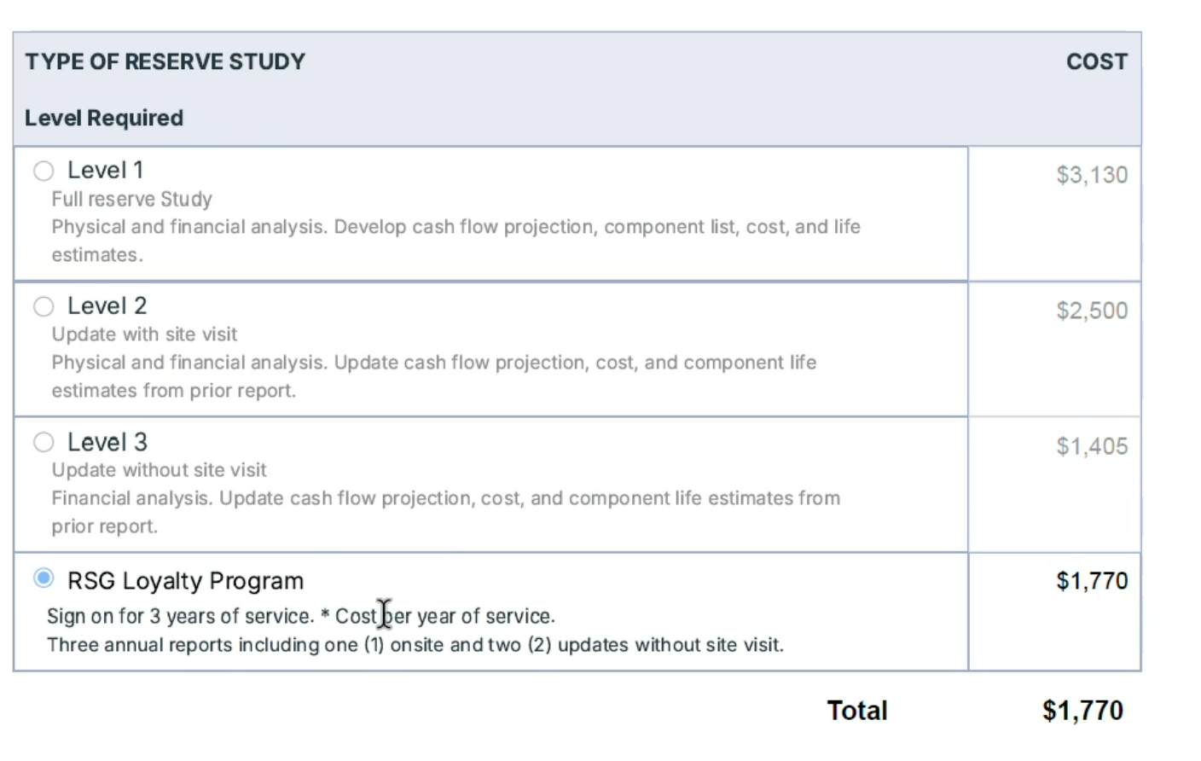
  - Board approves full reserve study with either after more thorough analysis. Will pick by Monday. Action Item: Olivia to get information both on regarding turnaround time for changes
- ACC Install EV Charger unit 11-301
  - Need more detailed proposal and coordination with Board because this is an unattached garage so we would have to run conduit.
  - Board authorizes EV Charger investigation
  - Action Item: Olivia to arrange meeting between proposed electrician and the board
  - Curtis notes that 7-202 wants to install a charger. Action Item: Curtis to get questions together for meeting for 11-301, and ask about 7-202’s proposed plan in the process
- Insurance Renewal
  - Kris has someone for an additional bid for comparison
  - Tyler will reach out to Dustin and Daniel for recommendation
  - Action item: get other recommendations asap because we need to return by mid July. Make sure not to overlap with the Insurance companies we currently sued. Olivia will see if we’re allowed to cancel after signing
Motion to adjorn 8:01

