2026-08-24 Mercer Park HOA Open Session
- Board discussed and approved EV Installation Proposal by 11-30
- Still waiting to hear from detailed proposal for 7-202
- Sue (Owner 9-302) presented appeal regarding the illegal tree trimming
  - Tried several times to contact Association to address the issue.
  - June 21 emailed Juan about overgrown branches including photographs encroaching on balcony and bedroom window. Worried about damage during storms, light and air flow. Requested selective pruning
  - 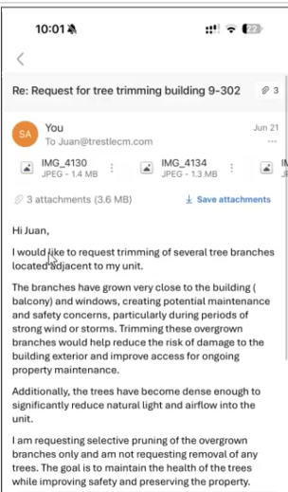
  - No response. Followed up on June 23
  - Tried to call on July 7 using Juan’s direct phone number but could not reach anyone (showed call log). Left voice message but no reply
  - Recognizes that they should have continued to get authorization before doing it themselves.
  - Asks to waive the fine since there was no response to using the official process, or reducing the amount or issuing a warning instead.
  - Board asked for Sue to forward the emails to the management email. Explained the context for the fine.
- Sue asked if she could be contacted when we send the arborist out. We might get an update next week at the monthly board meeting
Board adjourned into executive session to discuss the appeal. Decided to wait until the monthly meeting for updates about the arborist before making.
- Adjourn 7:20

