August 31, 2026
Call to order 6:33
Summary and Action Items
- Authorized Board to follow up ongoing projects to transition to SUHRCO outside of official meetings
- Sign hanging in tree at 3-201 is against the rules. Palong to SUHRCO to contact the agent to tell them to take it down
- Kris to make a map where electricity switches are in all buildings
- Board to reserve a future Monday session to discuss strategy for siding replacement
- Curtis to show Linnie how do to parking enforcement
- Prof to contact Erica about planning Fall social
- Curtis to make video on how to use line trimmer for volunteers
- Prof to set up Google Group for volunteers
- Kris to make sure maintenance items from monthly walkthroughs that we had Trestle pause get transferred to SUHRCO
Full Notes
Open Forum
- Linnie (3-202) shut down the water for the building, updated all neighbors to coordinate, but someone just moved in and didn’t get the notice so the city ended up coming out. No Action needed
- Prof on behalf of Carol: Unit for sale has sign hanging from tree (3-201), which is against the rules. Action Item: Pass this along to SUHRCO to contact the agent to tell them to take it down
- Kris: what happened with electricity on building 11? Electricity getting shut down in building 11. All switches in the box were in the off position. PSE came out and showed where to flip everything back on. Probably someone was trying to fix the issue from the shutoff notice and turned them the wrong way. Location: west side of building, door low underneath siding. Action Item: Kris - Make map where electricity switches are in all buildings.
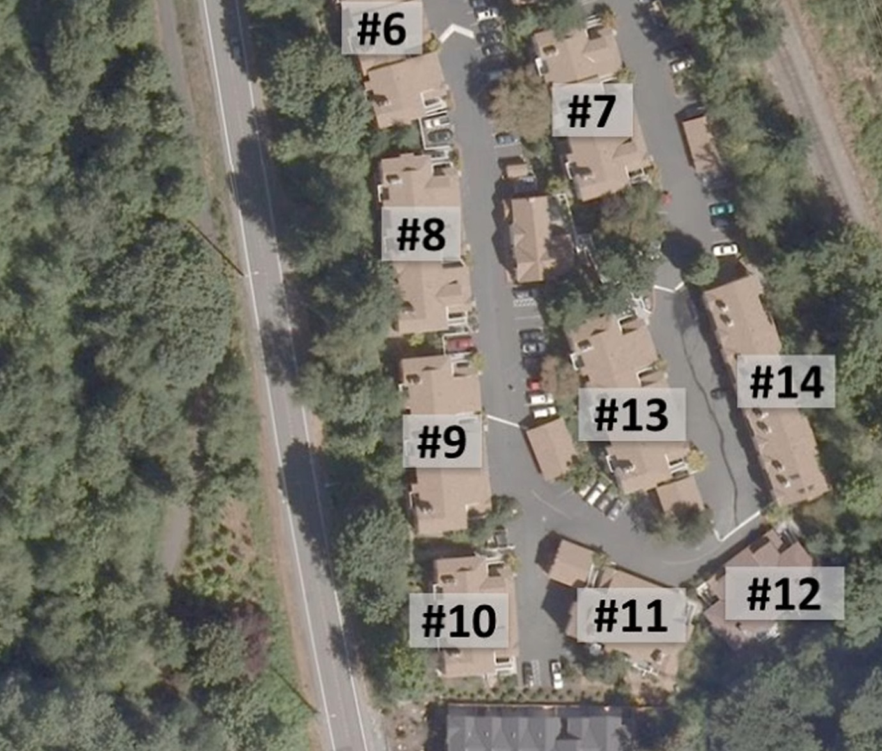

Old Business
Roof Issues:
- Deprioritize below siding and asphalt
Siding:
- When we replace siding, should do an entire wall at a time to try and minimize color differences
- Had a conversation about Hardyboard vs Vinyl, cheaper and longer-lasting but more painting
- Action Item: Board should have strategy sessions to work on this.
Parking enforcement
- Sean hasn’t been able to do regular walkarounds
- Linnie volunteered. Action Item: Curtis to get Linnie up and going. Meet Thursday at 9pm
Volunteer opportunities
- Plan fall social (Prof to contact Erica). Maybe we can invite SUHRCO project management
- Walking the property and identify spots where we need more plants so we know where to replant. Can figure out money for getting native plants
- Shed clean-up project. Figure out what to do with extra siding (need another shelf?)
- Storage room clean-up
- Linnie volunteered to help but we need to solicit strong people to help move stuff
- Prof’s habitat restoration stuff, fall planting
- Line trimming. Action item: Curtis to make video on how to use it
- Action Item: Prof to make a more explicit volunteer opportunity issue list for clubhouse
- Action Item: Prof to make google group for volunteers
Plan for SUHRCO
- Authorize the board to follow up on ongoing projects to transition to SUHRCO offline
- Prof to contact SUHRCO with this list (copy board)
This week (sooner the better)
- Figure out debit card and bank account stuff for board
- Getting settlement money into CDs as soon as possible
- What contact information should we put for management@mercerpark.org (do we have an email for our account specifically?)
Next Month
- Start on this week: Touch up painting and softwashing.
  - Painters for Hire seattle as a potential bid option. Board authorizes them to come on site and do a walkaround
  - Sound cleaning $50k for soft wash, Champion Power Wash wanted to meet onsite
  - Bids for soft wash, time and materials for painting
- Arborist come out to look at the Japanese maples and the building 9
- Get parking violation stickers with new info
- Follow up with Accurate Reserves to see if we are ready to sign a contract with them.
- Paying the backdated power bill for building 11, and follow up on all meters that were in Trestle’s name
- Follow up on dryer vent replacement (he was waiting on new covers)
- Did we ever submit for reimbursement to the garbage company for the curb repair (Cedar Creek Invoice, the first one for just the curb repair)
60 Days
- Follow up on unit EV proposal from 7-202 (we were waiting for his plan).
- Ledger review for anomalies (Kris as an example of out-of-whack account). May need to work directly with treasurer for audit. Have conversation at end of month meeting after the account transfers have happened.
- Figure out how to set up the monthly walkthrough process, have a handyman do it. Action Item: Kris to make sure maintenance items get transferred that we had Trestle pause
- Storm water system review (to try and figure out to get ahead of the big rain), Investigate cost of potential gutter revision

90 Days
- Night time walkaround to check parking lot lights once it gets dark

Include other action items from Blair’s email

Adjourn 7:57

